**LEADING UNVERSITY ESSENTIAL**

**BY**

**INCOGNITO CODERS**

**TEAM LEADER**

**SAJID ABDULLAH AL-HAFIZ**

**ID: 2012020308**

**KHADIZA AKTHER TOUHID HASAN BADHON**

**ID: 2012020295 ID: 2012020296**

**HUMAYRA KABIR NISA IFTEKHAR AHMED**

**ID: 2012020298 ID: 2012020302**

This Report Presented in Partial Fulfillment of the Requirements for the Sessional Course (Computer Programming Sessional, CSE – 1214 )

Supervised By

**Md Saidur Rahman Kohinoor**

Designation

Department of CSE

Leading University



**LEADING UNIVERSITY**

**SYLHET, BANGLADESH**

**24 OCTOBER 2020**

**APPROVAL**

This Project titled “LU Essential”, submitted by “Incognito Coders” consists of Sajid Abdullah Al-hafiz, Khadiza Akther, Touhid Hasan Badhon, Humayra Kabir Nisa and Iftekhar Ahmed to the Department of Computer Science and Engineering (CSE), Leading University, has been accepted as satisfactory for the partial fulfillment of the requirements for the course code: “CSE-1214”, course title: “Computer Programming Sessional” and approved as to its style and contents. The presentation has been held on 9, September 2020.

**BOARD OF EXAMINERS**

**_______________________**

**Md Saidur Rahman Kohinoor**

**Designation**

Department of CSE

Faculty of Modern Science

Leading University

**DECLARATION**

We hereby declare that, this project has been done by us under the supervision of **Md Saidur Rahman Kohinoor**,Faculty of Modern Science, Department of CSE Leading University. We also declare that neither thisproject nor any part of this project has been submitted elsewhere for award of any degreeor diploma.

**Submitted by:**

______________________

**Sajid Abdullah Al-hafiz**

**ID: 2012020308**

Department of CSE

Leading University

______________________

**Khadiza Akther**

**ID: 2012020295**

Department of CSE

Leading University

______________________

**Touhid Hasan Badhon**

**ID: 2012020296**

Department of CSE

Leading University

______________________

**Humayra Kabir Nisa**

**ID: 2012020298**

Department of CSE

Leading University

______________________

**Iftekhar Ahmed**

**ID: 2012020302**

Department of CSE

Leading University

**ACKNOWLEDGEMENT**

We are greatfull because we managed to complete our team project within the given time by our honourable teacher **Md. Saidur Rahman Kohinoor.** Thank You, respectful teacher, for all extra efforts you make to help us grow, and to encourage us to work of the project. You shared slides to make our course a lot easier and your teaching method is also amazing.

I also Thank the monitor of our project Hridoy Chowdhury brother for monitoring our team with good advice and help.

I thank our team members for working together to make it complete, and for working hard on time. This Project couldn’t be complete without the effort and cooperation of our team members.

**ABSTRACT**

Our project is basically about our campus leading university. There are 5 members

in our project. This is the first project in our life. Where to work on our project in the third year. But our sir has chosen so that we can learn the work of the project in advance. As if the ideas of our project are already there. So everyone thought a little differently because it was the first project. Actually the calculator or stop watch can be found by google searching. So we thought lets work on our campus.

Our bus schedule.Different The distance from the point to our campus.How much time is needed from different points to get to our campus. We have worked on these.

hen we worked on login logout registration. Our thinking was to do something different.So we worked with CGPA.Where a student can see his CGPA. At the end of the year a student will be able to find out hisdesired CGPA.

We had a lot of enjoy while projecting .A lot of new things have been learned.

**TABLE OF CONTENTS**

**CONTENTS PAGE**

Approval i

Declaration ii

Acknowledgements iii

Abstract iv

Table of Contents v

List of Figures vi

**CHAPTER**

**Chapter 1: Introduction** 1-3

1.1 Introduction 1

1.2 Motivation 2

1.3 Objectives 4-7

**Chapter 2: Background** 7

2.1 Project Planning

2.2 Relevant study & findings

2.3 Challenges

**Chapter 3: Requirement Specification**

3.1 Requirement Collection and Analysis

Logical Data Model/Flowchart/Pseudocode

**Chapter 4: Implementation and Testing**

4.1 Implementation of Database (file)

4.2 Testing Implementation (output analysis)

**Chapter 5: Time Plan and Team Work**

5.1 Work Distribution

5.2 Individual Contribution

5.2 Miscellaneous

**Chapter 6: Conclusion and Future Scope**

6.1 Learning and Conclusion

6.2 Scope for Further Developments

**REFERENCES** 15-16

**LIST OF FIGURES**

|  |  |
| --- | --- |
| **FIGURES** | **PAGENO** |
| **Beginning of Project** |  |
| **Registration** |  |
| **Log In** |  |
| **Profile** |  |
| **Services** |  |
| **CHOLO Leading University** |  |
| **Tracking Result** |  |

**CHAPTER 1**

**INTRODUCTION**

* 1. **Introduction**

The **Leading University Essential (LU Essential)** is a program which based on the Leading University website information. We invent some new features to assist university students. LU Essential will provides some information of our university, it’ll provides two types of assistance for the students. One is to ease their traveling matters from any route to Leading University and its exact time schedule and other is to track the CGPA of completed and incompleted semesters. Hopefully LU Essential will play important role for basic information.

* 1. **Motivation**

The **“LU Essential”** is demonstrate with the intention to help the students of Leading University. Our project is not only to ease the pain of distance from any route to Leading University but also will help the students to know how to go, which route to go, at what time the bus will be available etc and also to track their courses grade’s, GPA, CGPA and create registration in every semesters.

* 1. **Objectives**

Teaching and learning process has been modified from lecture-based learning to be more interesting and motivating learning environment with the use of modern technologies and variety of technological tools. Our code is developed with the intention to help users of this program to keep track of the distance and other registration related things.

**Goals**

1. It’ll assist in basic information.

2. To provides better understand of LU bus routes.

3. Maintaing time with the help of bus schedule.

4. To assist the students to track their desire Course Grade’s, GPA and CGPA of

specific course and semesters.

5. To provides better understand about registration/login for any purposes.

**CHAPTER 2**

**BACKGROUND**

**2.1 Project Planning**

**Generating Idea**

At first, when we talked about project ideas with our team mates, there appears miscellaneous ideas like Scientific Calculator, Snake game, Stop Watch, Calculating Desire CGPA and Traveling aid of LU routes same as UBER/PATHAO app.

After all, we decided to develop a project on Traveling aid of LU Routes and Predicting Results by calculating Course Grade’s, GPA and CGPA.

First, we planned to collect information for Traveling aid of LU. We named that part as “CHOLO LU”. We gather info of the four routes of Leading University from google map. Our target was finding minimum distance and time from any location of any of four routes to LU. Second, we learned how to calculate GPA and CGPA. At last, we convert those knowladges into code and shaped the project.

**2.2 Relevant study & findings**

We searched for many things and learned to make our project interesting and decorate the User Interface (UI) and tried to give a descent outlook.

Here’re few questions that asked for betterment of the project.

1. How to calculate GPA & CGPA and what is the differences?
2. How to animate characters in C?
3. How to change forground and background color?
4. How to control multiple files under one project?

**2.3 Challenges**

The most challenging part was assembling the whole project and debugging the errors. I did not learn how to divide a project into smaller parts before doing this project. So it seemed difficult to share the project and explain the work to the teammates.

**CHAPTER 3**

**REQUIREMENT SPECIFICATION**

**3.1 Requirement Collection and Analysis**

Logical Data Model/Flowchart/Pseudocode

**Character Animation**

Pseudocode:

* Storing a string in a character array.
* Create a loop to continue for million or required times and close.
* Create another loop to print the stored string character by character.

**Coding syntext thakbe na/write like algorithm**

Code in code::blocks IDE:

int x;

double y;

char text[] = "CHARACTER ANIMATION";

for( x = 0; text[x] != '\0'; x++)

{

printf("%c", text[x]);

for( y = 0; y <= 9999999; y++)

{

}

}

**Registration**

Pseudocode:

* Open a file in append mode.
* If file is NULL, which means file doesn’t exist.
* Store data to the opened file.
* Close file.

**Log In**

* The first part is the actual login from which user fills out and kicks off the login process.

2. The second is the login mechanism which will take the submitted username and password,

find the user’s password in the database and compare their password on file to the one they

provided as part of the login.

3.The third part is then checking a user on each restricted page to see if they have successfully

logged in.

4. Lastly we need a mechanism for destroying that user’s state and basically causing them to go

and login again. (logout)

**Profile**

Pseudocode:

* Open the exist file in reading mode.
* Read data from the file.
* Print those data on the screen.
* Close the file.

**CHAPTER 4**

**IMPLEMENTATION AND TESTING**

**4.1 Implementation of Database (file)**

FILE is used for the purpose of collecting and storing data in to the system so that the stored data can be reused in other work. Here, we used FILE for the same purpose. At first a Text file was created which contain the Name, ID, E-mail, Password etc. some personal data of a student. Which helps students to make their own profile.

**4.2 Testing Implementation (output analysis)**

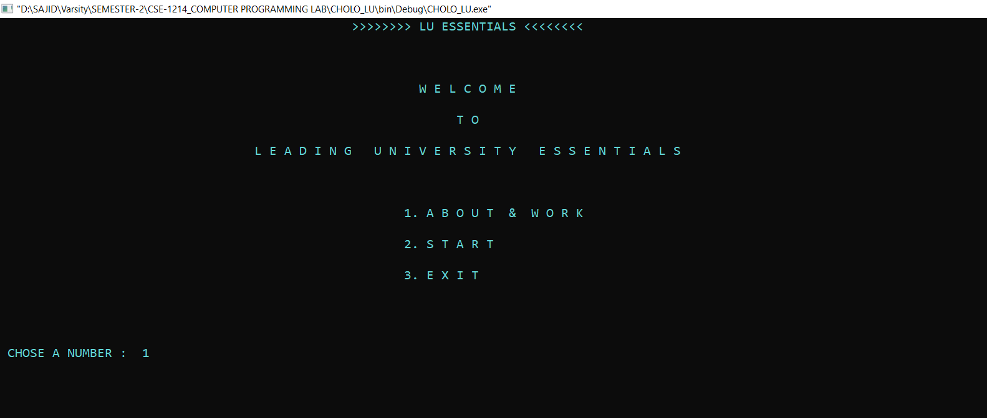

**FEGURE - 4.1 : Beginning part of the project.**

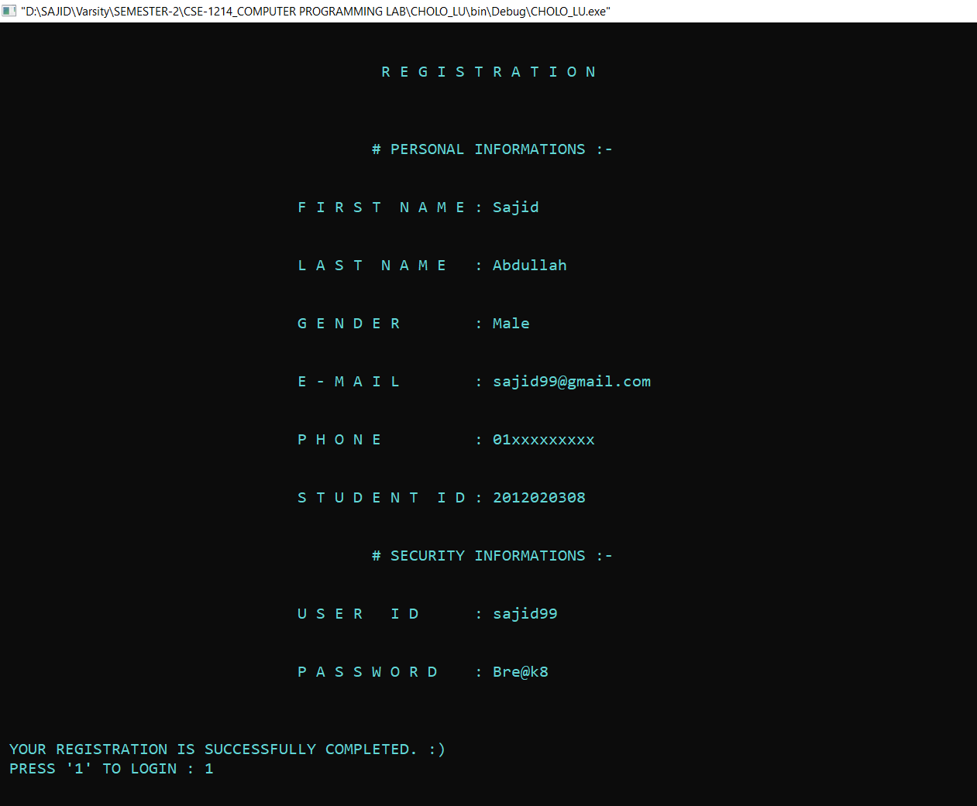

**FEGURE - 4.2 : Registration completion.**

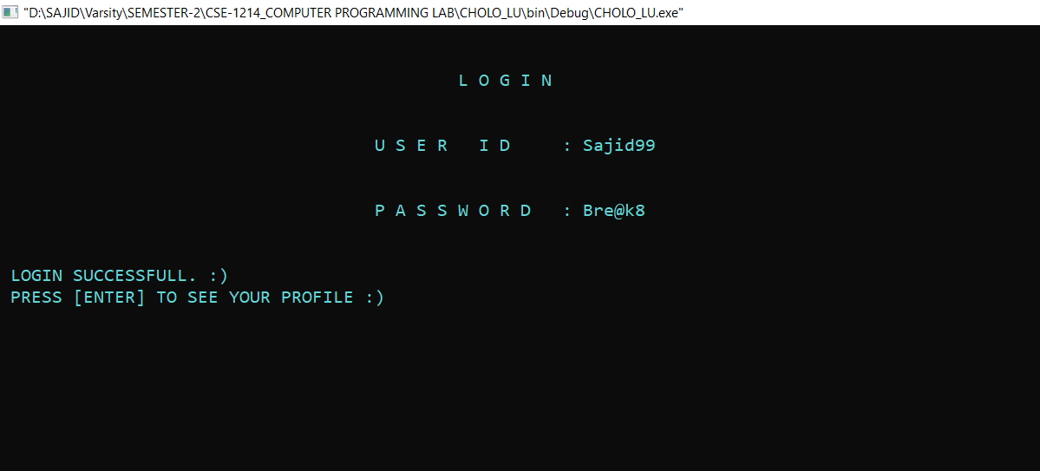

**FEGURE - 4.3 : Log In.**

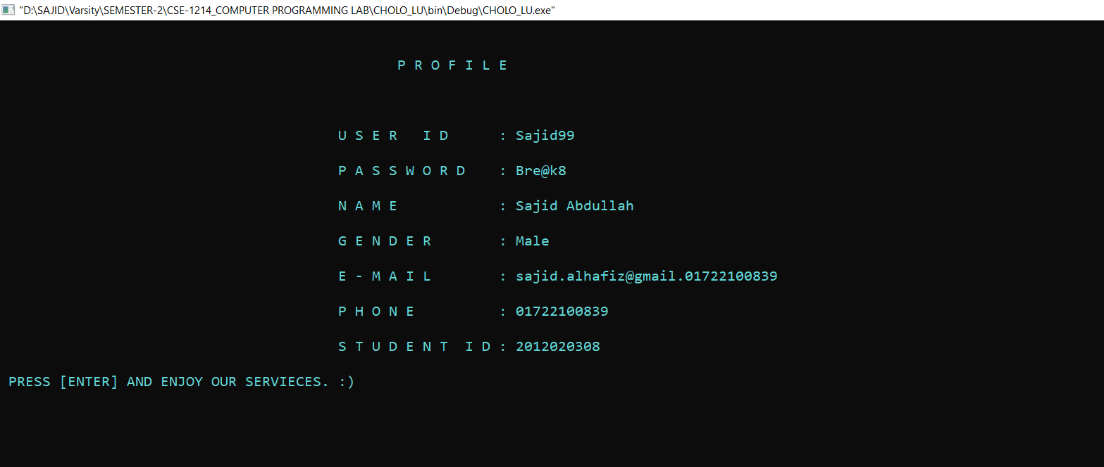

**FEGURE - 4.4 : Profile.**

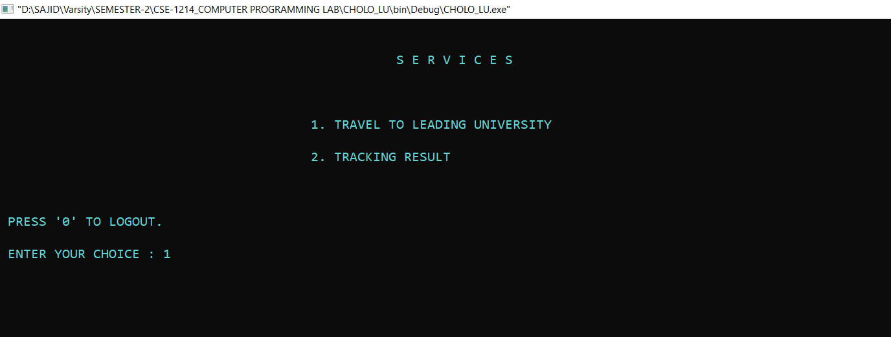

**FEGURE - 4.5 : Services of the project.**

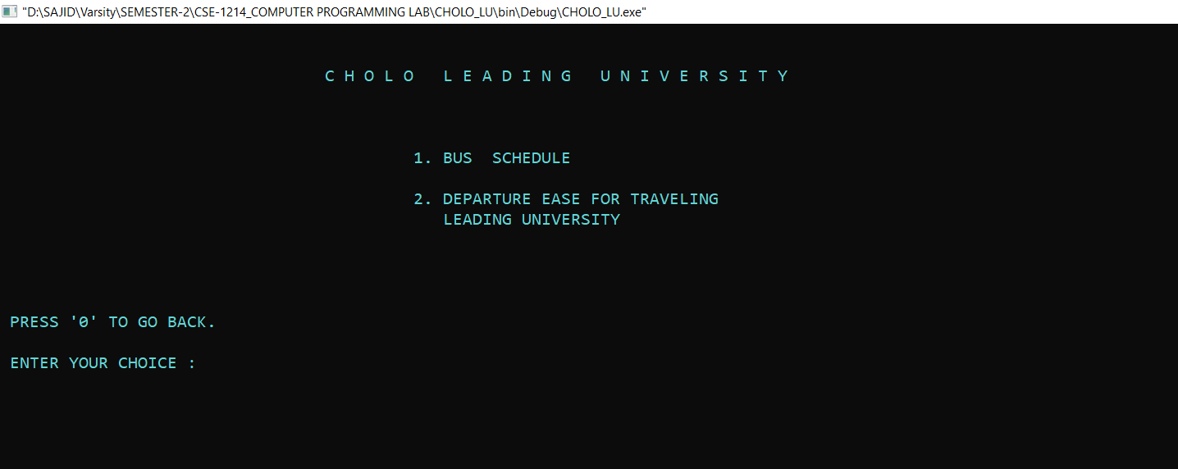

**FEGURE - 4.6 : First part of services list, CHOLO LU.**

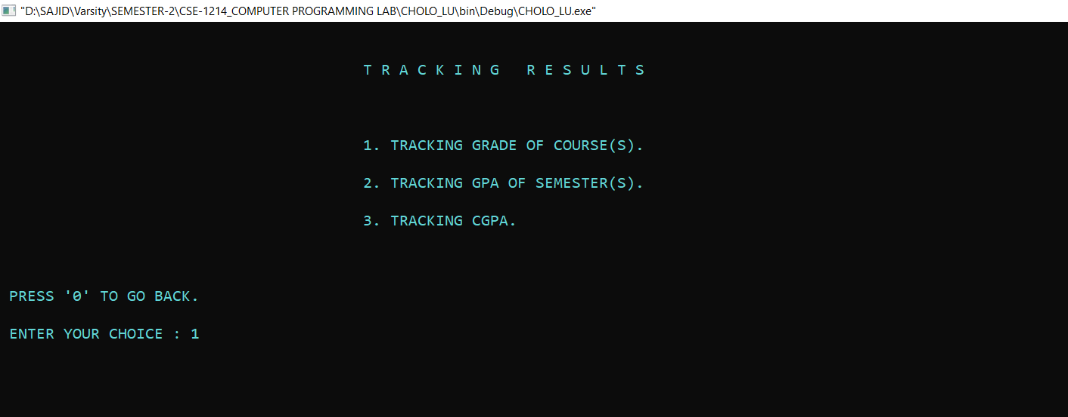

**FEGURE - 4.7 : Second part of services list, Tracking Result.**

**CHAPTER 5**

**TIME PLANE AND TEAM WORK**

**5.1 Work Distribution**

First I divided our project into smaller parts and distribute the task among the team members considering the difficulty of the work and the skills of the members.

Here I’m trying to show the layout of the project tasks below.

**LU ESSENTIAL**

**USER INFO** **TRAVEL TO LU** **TRACKING CGPA**

REGISTRATION BUS SHEDULE GRADE

LOGIN LIST OF BUS STOPPAGES COURSE GRADE

PROFILE BUS ROUTES GPA

ROUTE-1 CGPA

ROUTE-2

ROUTE-3

ROUTE-4

**5.2 Individual Contribution**

**Sajid Abdullah Al-hafiz**

As a team leader, I was responsible for managing the whole project. I had to layout the project task and assign each task to my teammate. Collecting, editing and evaluating their works was part of my duty. I had to debug some of their code and make it smooth and more optimized for the project. Many of the time I had to give Logical support to my teammates.

Assembling the whole project, designing and implementing was work of mine. Where I had animated characters, changed the color of fourground and background, aligning contents to the center and make it more dynamic. I also created the profile function which contain the information of the registered user.

**Humayra Kabir Nisa**

She created the Registration function. For which, the function asks user to provide their personal and security information in detailed. These data will store in a file so that program can reuse the data for Log In purpose.

She was also given the task to collect collected the minimum distance and amount of time intended to ease the complexity of traveling to LU from each stoppages of Bus Route-1.

**Khadiza Akther**

She attached LU's regular bus schedule and collected the minimum distance and amount of time intended to ease the complexity of traveling to LU from each stoppages of Bus Route-2.

Regular Bus schedule shows the departure and return time of the number of Bus of each routes. When user chose option to see the bus schedule, it will display route wise detailed information.

She also assisted me in recurrecting, designing and analyzing the project report.

**Touhid Hasan Badhon**

He was given the task to create the Log In function. When User completed the registration, he become able to Log In. Firstly, Log In function will ask the user to give the correct UserID and Password to enter in his account. After that, the function match the newly given UserID and Password with earlier given UserID and Password from the file which was created in the registration section. If UserID and Password matches user can successfully log in.

He collected the minimum distance and amount of time intended to ease the complexity of traveling to LU from each stoppages of Bus Route-3 and he has wrote the Abstruct of our project report.

**Iftekhar Ahmed**

He was created the CGPA Tracking Calculater. This tracking result function has four parts.

1. Grade
2. Tracking Course Grade
3. Tracking GPA
4. Tracking CGPA

Grade part is used to convert the foat value to a grade. The Course Grade, GPA and CGPA tracking function has similar type of calculation. If user choose the Tracking Course Grade option, it will ask him the marks of exam’s, assignment’s, tutorial’s etc.

He collected the minimum distance and amount of time intended to ease the complexity of traveling to LU from each stoppages of Bus Route-4.

**5.3 Miscellaneous**

**Iftekhar Ahmed & Sajid Abdullah Al-hafiz**

We worked together to implement the CGPA Tracking Calculater. At first, we learn that how to calculate GPA and CGPA. Than we find a video of an application named “Grade Expert” which motivated us develop and invent The CGPA Tracking Calculator same as the app.

Whole code of the functions under CGPA Tracking Calculator was created by Iftekhar Ahmed in C++ programming language with my cooperation. I converted the codes in C programming language. I made it dynamic, smooth and more optimized for the project.

**CHAPTER 6**

**CONCLUSION & FUTURE SCOPE**

**6.1 Learning and Conclusion**

**Our** project was started with the intention to invent some new features in the Leading University website. Therefore, we generated ideas and implemented in the project. The

**6.2 Scope for Further Developments**

I think there’re two types of scope for further development in our project.

These are –

1. **Canceling Ragistration**

We have been able to create a personal profile by registering students in our project. But I failed to give them the freedom to cancel the registration.

1. **Tracing Desire CGPA**

By measuring the desired CGPA of our semester or the desired GPA of a particular course, we can get an idea that it is possible to get the desired grade by getting the minimum number of marks in a subject.